**Part I**

**Setting Up NIOS II**

Nios II – is a 32-bit embedded softcore microprocessor (a microprocessor than can be implemented by logic synthesis on an FPGA)

Setting up the NIOS II system, was a relatively trivial task –following the tutorial correctly was all that was required.

We first performed this on the DE2-70 board, and then later on the DE0 board. As we were one of the first groups to do this – we found there was an issue with the compiling of Quartus projects on the lab computers – they have to be compiled on the H:/ drive rather than the mapped \\ic.ac.uk\homes\ drive. Once this issue was overcome we proceeded on to the next problem.

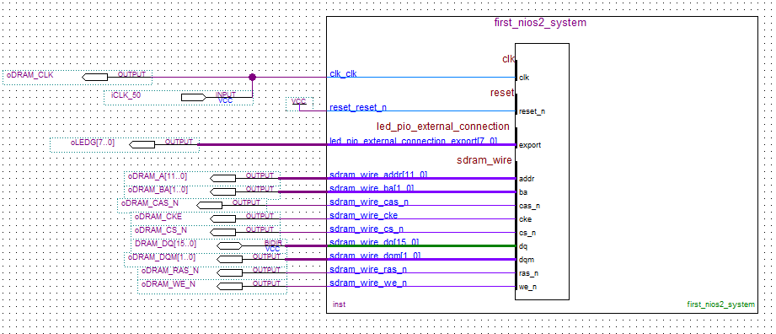

The system was then tested using count binary and the hello_world example files set out in the NIOS II Eclipse software.

**Determinant Square Matrix in Software**

The determinant of a 3x3 Matrix performed in software was done on the NIOS II. We used the LU Decomposition method to find the determinant of the matrix. In practice the amount of computer time used to calculate the speed of a program is proportional to the arithmetic and storage operations used to calculate the result. Using this measure we can calculate the LU decomposition of an NXN matrix to be ${ n}^{3}-\frac{n}{3}=O({n^{3}}/3)$. However a recursive method for finding the determinant of an NxN matrix is O(n!) . (K Eriksson – Computational Differential Equations 1996)

float determinant**(**float **\***matrix**,** int dimension**){**

int i**,** j**,** p**;**

float a**,** result**;**

float **\***m**;**

// Let us copy the matrix first

m **=** **(**float **\*)** malloc**(** **sizeof(**float**)\***dimension**\***dimension **);**

memcpy**(**m**,** matrix**,** **sizeof(**float**)\***dimension**\***dimension **);**

// First step: perform LU Decomposition using Doolittle's Method

// This algorithm will return, in the same matrix, a lower unit triangular matrix

// (i.e. diagonals one)

// and an upper trangular matrix

// https://vismor.com/documents/network_analysis/matrix_algorithms/S4.SS2.php

**for** **(**i **=** 0**;** i **<** dimension**;** i**++){**

**for** **(**j **=** 0**;** j **<** i**;** j**++){**

a **=** getAt**(**m**,** i**,** j**,** dimension**);**

**for** **(**p **=** 0**;** p **<** j**;** p**++){**

a **-=** getAt**(**m**,** i**,** p**,** dimension**)** **\*** getAt**(**m**,** p**,** j**,** dimension**);**

**}**

putAt**(**m**,** i**,** j**,** dimension**,** a**/**getAt**(**m**,** j**,** j**,** dimension**));**

**}**

**for** **(**j **=** i**;** j **<** dimension**;** j**++){**

a **=** getAt**(**m**,** i**,** j**,** dimension**);**

**for** **(**p **=** 0**;** p **<** i**;** p**++){**

a **-=** getAt**(**m**,** i**,** p**,** dimension**)** **\*** getAt**(**m**,** p**,** j**,** dimension**);**

**}**

putAt**(**m**,** i**,** j**,** dimension**,** a**);**

**}**

**}**

// Second step is to find the determinant.

// Because the lower triangle is a unit triangular matrix

// the determinant is simply a product of all the upper triangle diagonal

// which in this case is exactly the diagonal of m

result **=** 1**;**

**for** **(**i **=** 0**;** i **<** dimension**;** i**++)**

result **\*=** getAt**(**m**,** i**,** i**,** dimension**);**

free**(**m**);**

**return** result**;**

**}**

// Based on i and j, and a float pointer, get the value at row i column j

float getAt**(**float **\***m**,** int i**,** int j**,** int dimension**){**

**return** **\*(**m **+** i**\***dimension **+** j**);**

**}**

// Based on i and j, and a float pointer, put the value at row i column j

void putAt**(**float **\***m**,** int i**,** int j**,** int dimension**,** float value**){**

**\*(**m **+** i**\***dimension **+** j**)** **=** value**;**

**}**

Calculation of the 3X3 matrix took - 0.009 for 10 iterations.

**SDRAM**

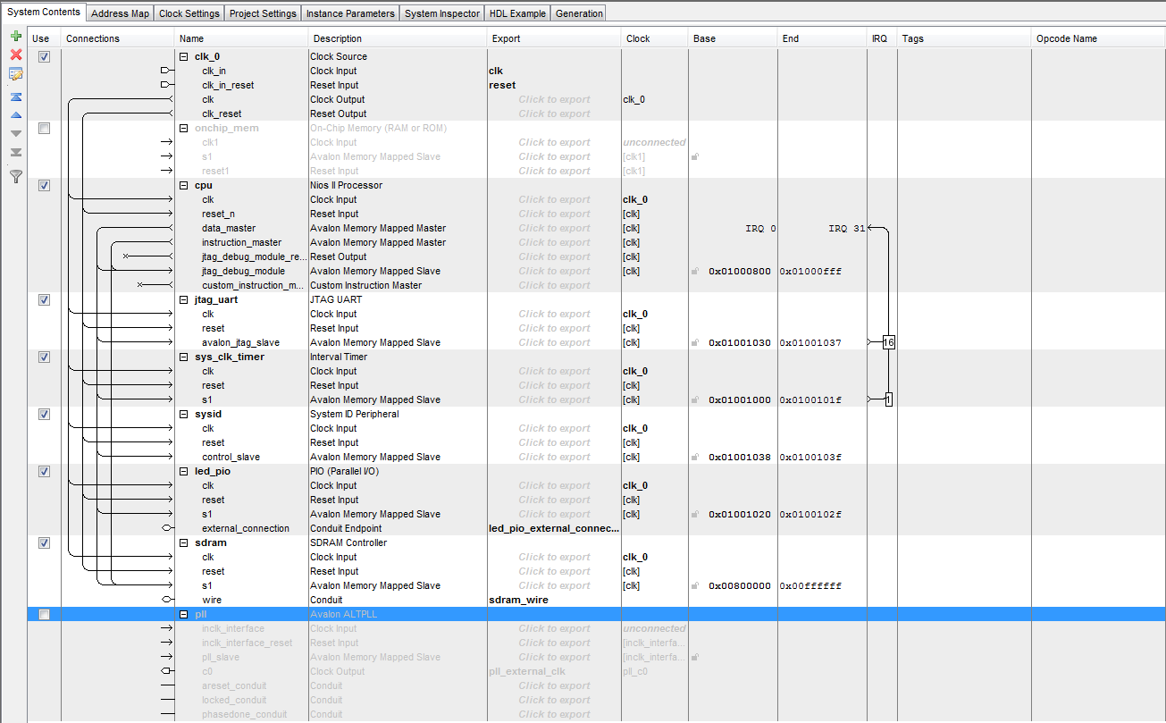

3x3 Matrix SDRAM 100 iterations 0.077 s

6x6 Matrix SDRAM 100 iterations 0.537 s

8x8 Matrix SDRAM 100 iterations 1.245 s

10x10 Matrix SDRAM 100 iterations 2.494 s

20x20 Matrix SDRAM 100 iterations 20.343 s

As the SDRAM is very sensitive to clock variations we added a PLL with a time-shift of 2.55ns. A PLL is a phase-locked loop, this is a closed loop feedback system based on the difference in phase between the clock input and a clock signal of a controlled oscillator.

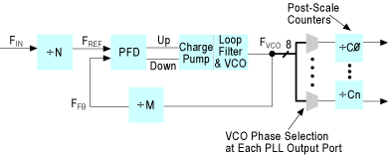

N – a pre-scale counter, PFD – phase frequency detection, VCO voltage controlled oscillator, M – a feedback counter, N – a pre-scale counter and C - post-scale counters.

Image Source http://www.altera.com/support/devices/pll_clock/images/fig_07_00_PLL_block.gif

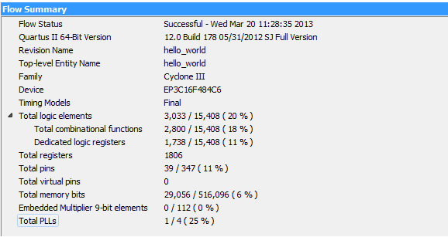

From this image we can see that on the DE0 board – the NIOS2 and SDRAM with a PLL takes up 20% of the logic elements and 6% of the total memory.

**Embedded Multipliers**

Embedded Multipliers are configured as either one 18 x 18 multiplier or two 9 x 9 Multipliers, the Cyclone III chip on the DE0 board has 112 Embedded 19x19 multipliers.

Times and Sizes

3x3 Matrix SDRAM With embedded multipliers 100 iterations 0.044s

6x6 Matrix SDRAM With embedded multipliers 100 iterations 0.283s

8x8 Matrix SDRAM With embedded multipliers 100 iterations 0.658s

10x10 Matrix SDRAM With embedded multipliers 100 iterations 1.278s

20x20 Matrix SDRAM With embedded multipliers 100 iterations 10.669s

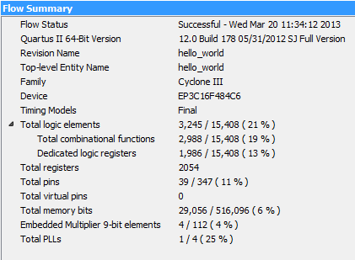

Using Embedded Multipliers uses 1% (212) more logic elements on the board, and uses an additional 4 Embedded Multipliers. It uses 248 more registers.

**LUT – based Multipliers**

In addition to embedded multipliers, there are also look-up tables on the cyclone II chip created from M9K memory blocks. Look-up tables are implemented using very small amounts of RAM, and are used to implement combinational logic – for example an N-input LUT can implement any Boolean function of N inputs.

Times and sizes –

3x3 Matrix SDRAM with LUT based Multipliers 0.045s

6x6 Matrix SDRAM with LUT based Multipliers 100 iterations 0.286s

8x8 Matrix SDRAM with LUT based Multipliers 100 iterations 0.666s

10x10 Matrix SDRAM with LUT based Multipliers 100 iterations 1.293s

20x20 Matrix SDRAM with LUT based Multipliers 100 iterations 10.72s

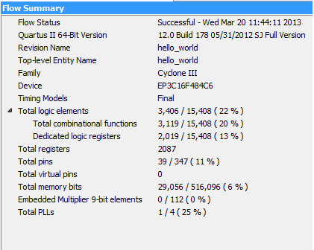

Using LUTs uses 2% more logic elements than the SDRAM alone, 281 more registers.

From the data and the graph it can be seen that the SDRAM alone is the slowest for all Matrix dimensions and Embedded Multipliers are the fastest. However there are only a few tens of milliseconds difference over 100 iterations between the LUT and Embedded Multipliers, this will make a minimal difference over 1 iteration – however if we were to want to do one million iterations of a 20x20 matrix would make a 510 second difference between using LUTs and Embedded Multipliers, so in terms of speed it makes sense to use Embedded Multipliers.

However on the DE0 board there are only 112 Embedded multipliers, but 15000 Lookup tables – so if a larger project was undertaken then it would be sensible to put the most time sensitive calculations onto Embedded Multipliers and the rest on to the Lookup tables.

**Floating Point Hardware**

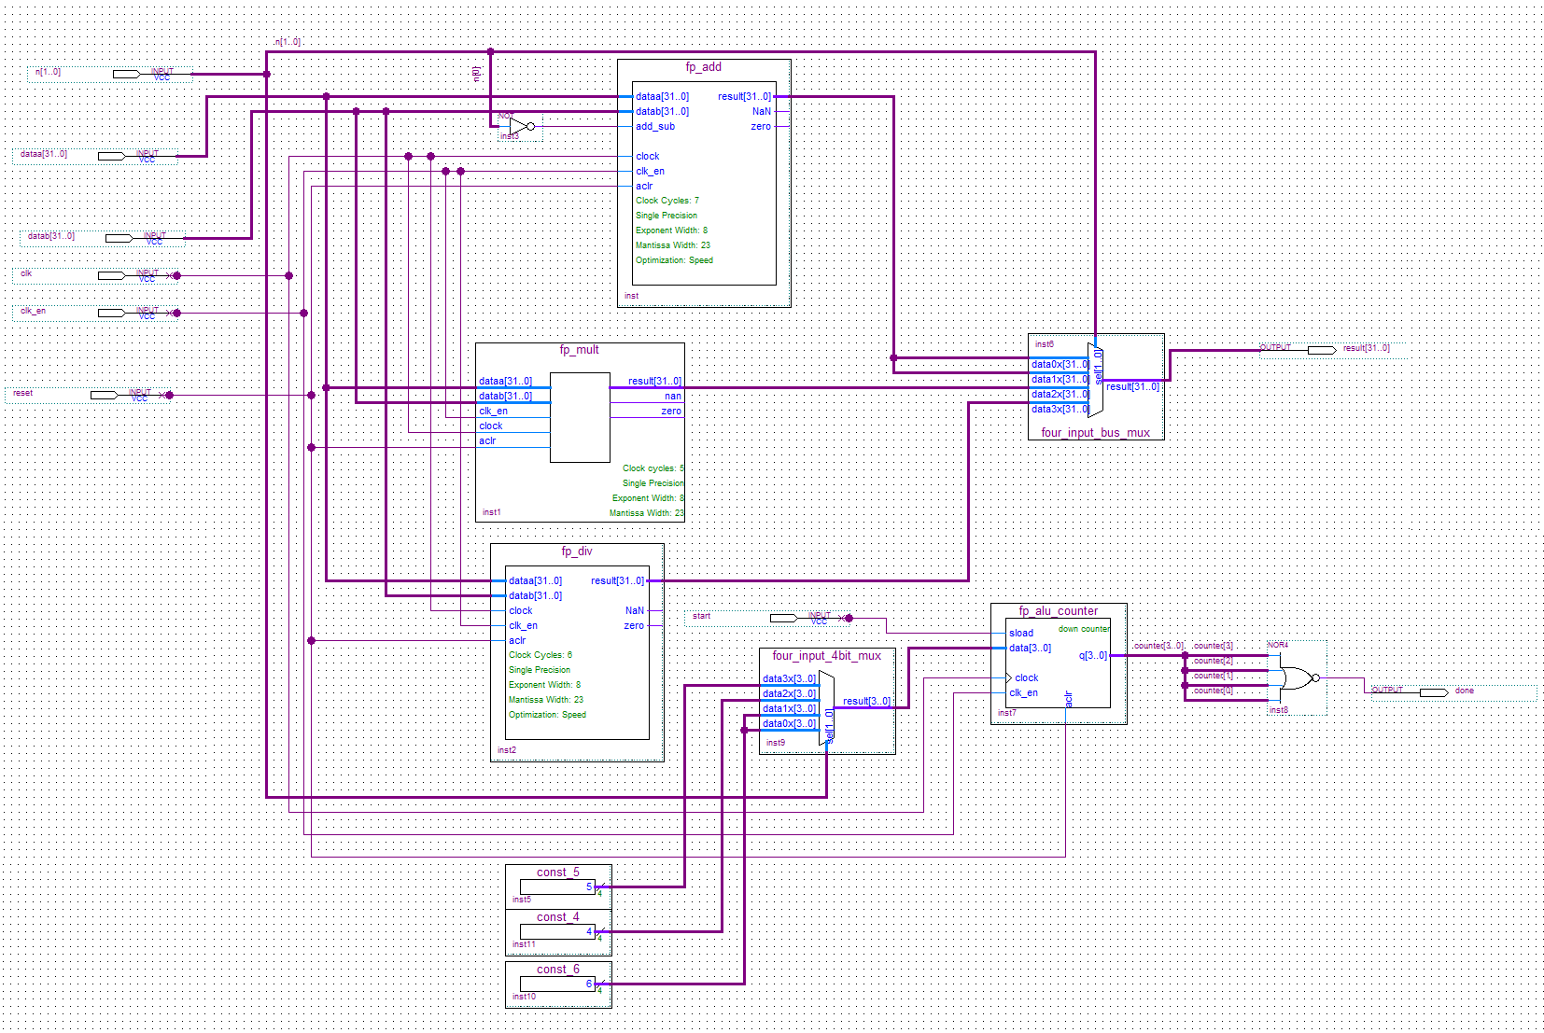

To create the floating point custom instruction hardware, the megawizard function blocks were used. The exponent and mantissa widths were set to 8 bits and 23bits respectively for all blocks. The latency for the floating point blocks were

Code area vs. code size vs execution speedup.

3x3 Floating Point 100 iterations 0.016s

6x6 Floating Point 100 iterations 0.035s

8x8 Floating Point 100 iterations 0.058s

10x10 Floating Point 100 iterations 0.09s

20x20 Floating Point 100 iterations 0.489s

Using Hardware Floating Point Instructions

float determinant**(**float **\***matrix**,** int dimension**){**

int i**,** j**,** p**;**

float a**,** result**;**

float **\***m**;**

// Let us copy the matrix first

m **=** **(**float **\*)** malloc**(** **sizeof(**float**)\***dimension**\***dimension **);**

memcpy**(**m**,** matrix**,** **sizeof(**float**)\***dimension**\***dimension **);**

// First step: perform LU Decomposition using Doolittle's Method

// This algorithm will return, in the same matrix, a lower unit triangular matrix

// (i.e. diagonals one)

// and an upper trangular matrix

// https://vismor.com/documents/network_analysis/matrix_algorithms/S4.SS2.php

**for** **(**i **=** 0**;** i **<** dimension**;** i**++){**

**for** **(**j **=** 0**;** j **<** i**;** j**++){**

a **=** getAt**(**m**,** i**,** j**,** dimension**);**

**for** **(**p **=** 0**;** p **<** j**;** p**++){**

a **=** fp_sub**(**a**,** fp_mul**(** getAt**(**m**,** i**,** p**,** dimension**),** getAt**(**m**,** p**,** j**,** dimension**))** **);**

**}**

putAt**(**m**,** i**,** j**,** dimension**,** a**/**getAt**(**m**,** j**,** j**,** dimension**));**

**}**

**for** **(**j **=** i**;** j **<** dimension**;** j**++){**

a **=** getAt**(**m**,** i**,** j**,** dimension**);**

**for** **(**p **=** 0**;** p **<** i**;** p**++){**

a **=** fp_sub**(**a**,** fp_mul**(** getAt**(**m**,** i**,** p**,** dimension**)** **,** getAt**(**m**,** p**,** j**,** dimension**)));**

**}**

putAt**(**m**,** i**,** j**,** dimension**,** a**);**

**}**

**}**

// Second step is to find the determinant.

// Because the lower triangle is a unit triangular matrix

// the determinant is simply a product of all the upper triangle diagonal

// which in this case is exactly the diagonal of m

result **=** 1**;**

**for** **(**i **=** 0**;** i **<** dimension**;** i**++)**

result **=** fp_mul**(**result**,** getAt**(**m**,** i**,** i**,** dimension**));**

free**(**m**);**

**return** result**;**

**}**

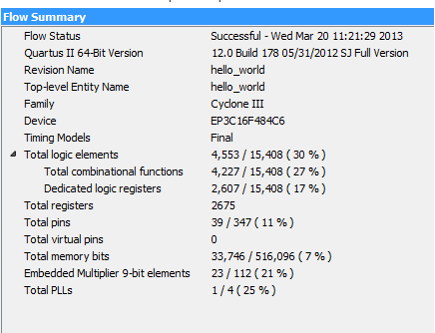

Adding a floating point Arithmetic and Logic unit to calculate the determinant of the matrix has increased the number of logic elements by 9% of the total available The total memory usage increased by 1% and the number of embedded multipliers used has increased by 19 elements (17%).

When choosing floating point units to use the Altera Mega Wizard allows the user to select the latency of each Floating Point operator -

**Possible extensions to the project**

**Multiple NIOS II on the FPGA – should in theory be able to get 4 NIOS II on the FPGA.**